**Solution**

I tried to analyse this file using the method from the description, but it was impossible because of some unexpected errors below screenshot.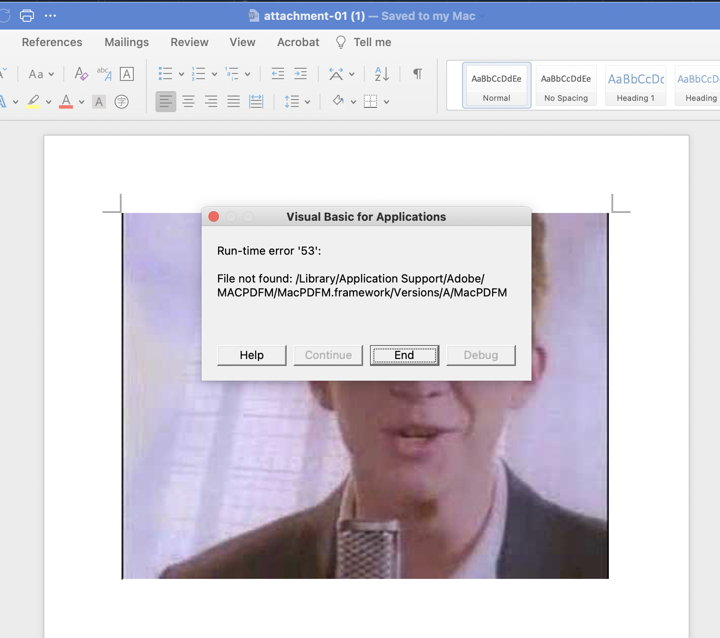

I made a zip file using the same skill from the description, but I cannot open the zip file.

I don’t know the correct reason for these circumstances, but I can tell this file is faulty and has some problems.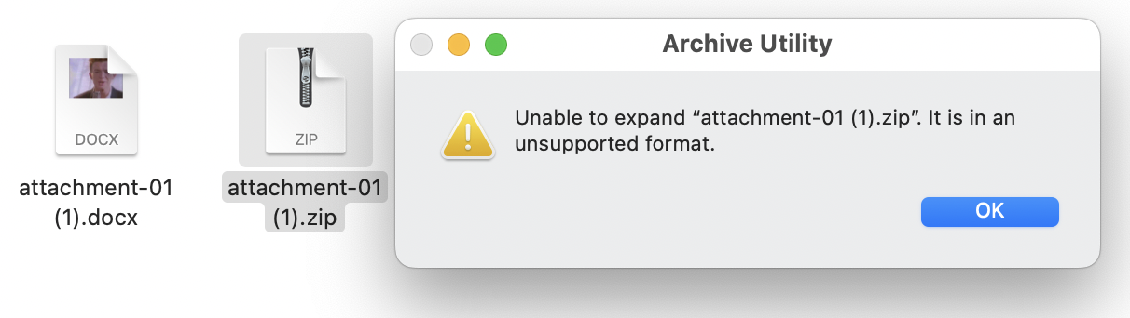

However, I couldn’t go through further analysis because of these problems.